**ADVANCE DEVOPS EXP 8**

**Name:Soham Satpute**

**Class:D15A Roll No:52**

**Aim:** Create a Jenkins CICD Pipeline with SonarQube / GitLab Integration to perform a static analysis of the code to detect bugs, code smells, and security vulnerabilities on a sample Web / Java / Python application.

**Step 1: Download sonar scanner** [https://docs.sonarsource.com/sonarqube/latest/analyzing-source-code/scanners/sonarscan](https://docs.sonarsource.com/sonarqube/latest/analyzing-source-code/scanners/sonarscanner/)

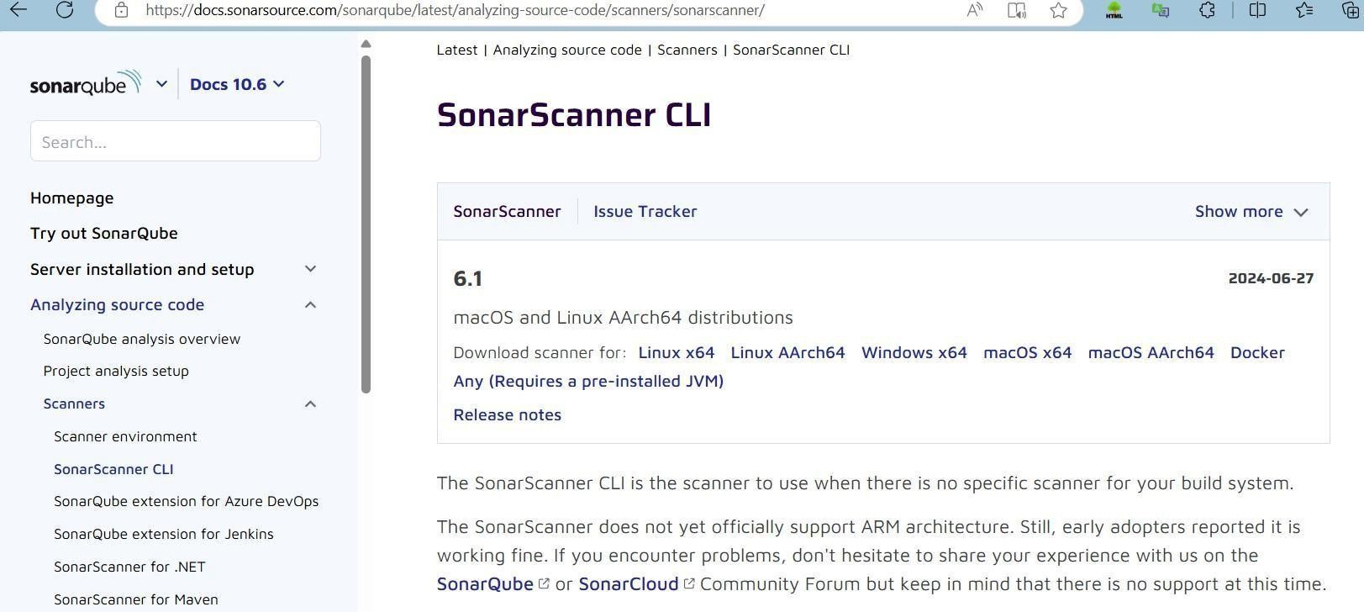

[ner/](https://docs.sonarsource.com/sonarqube/latest/analyzing-source-code/scanners/sonarscanner/) Visit this link and download the sonarqube scanner CLI.

Extract the downloaded zip file in a folder.

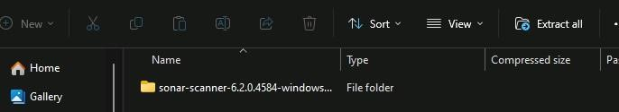

1. Install sonarqube image Command: **docker pull sonarqube**

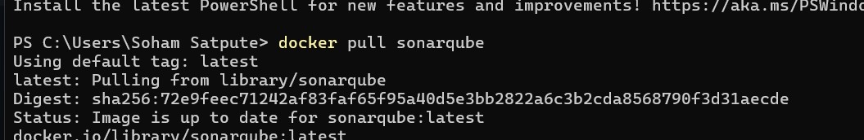

1. Once the container is up and running, you can check the status of

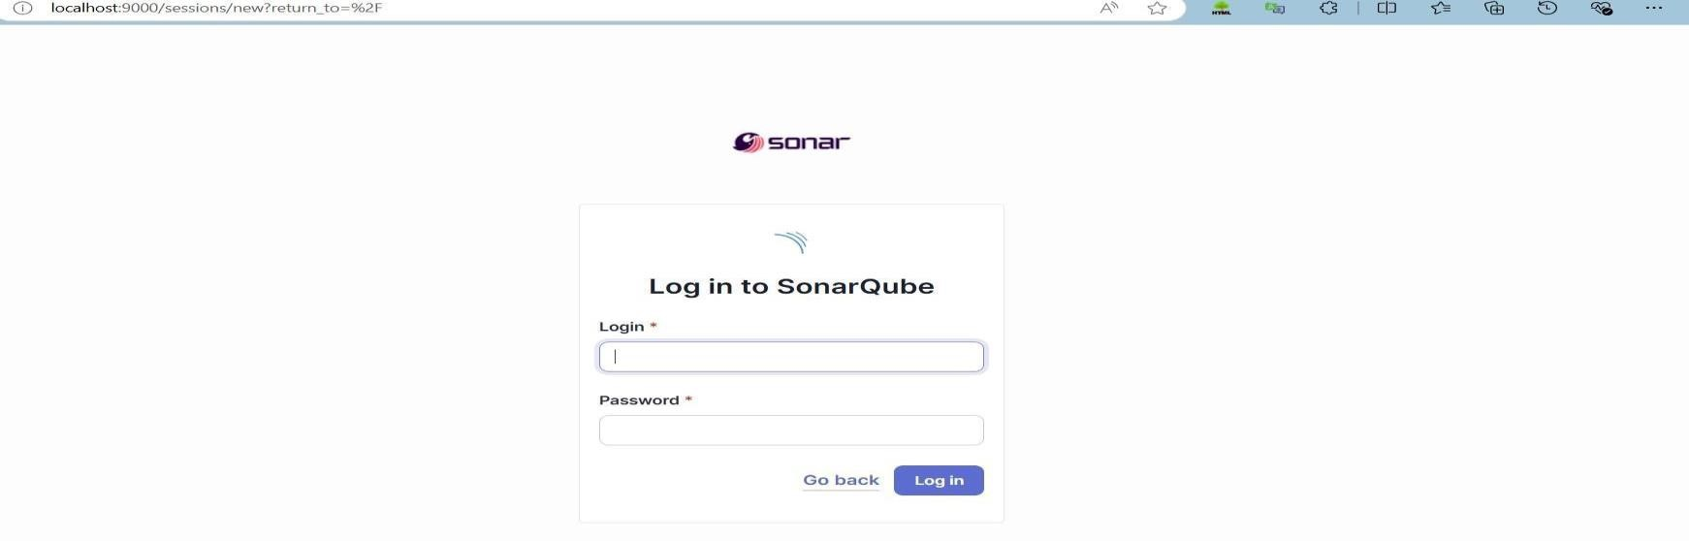

SonarQube at localhost port 9000.

1. Login to SonarQube using username admin and password admin.

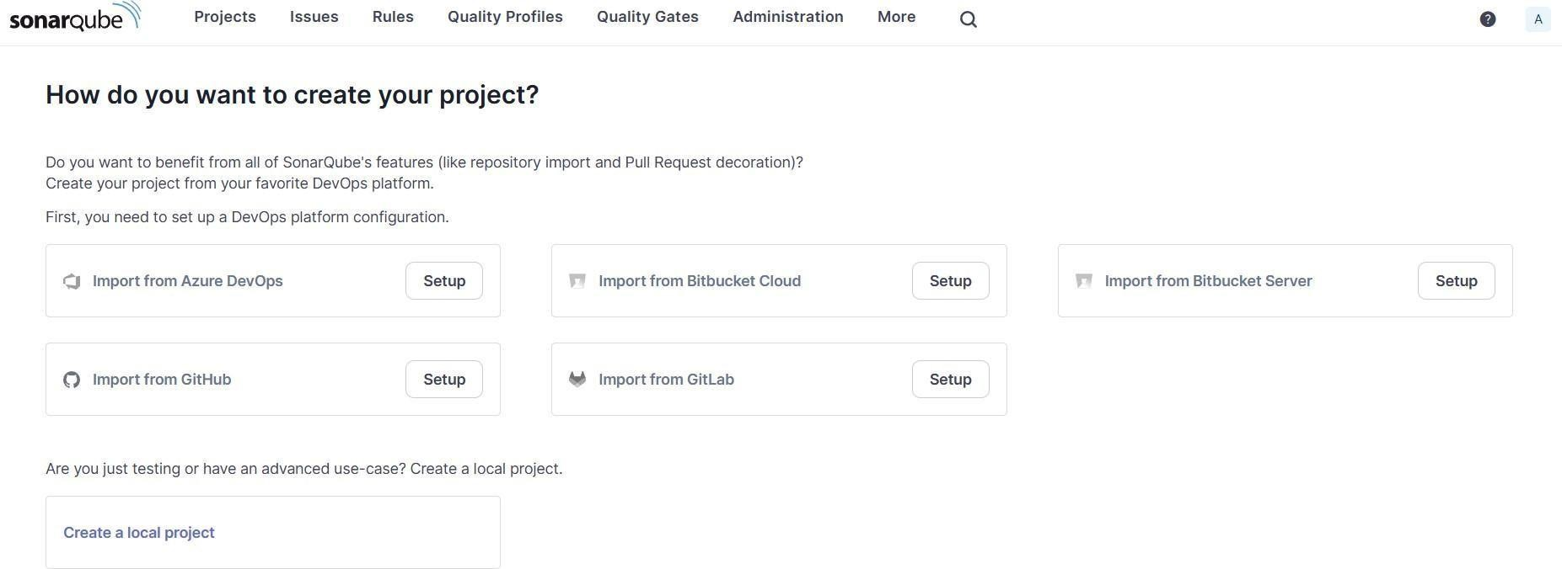

1. Create a manual project in SonarQube with the name sonarqube

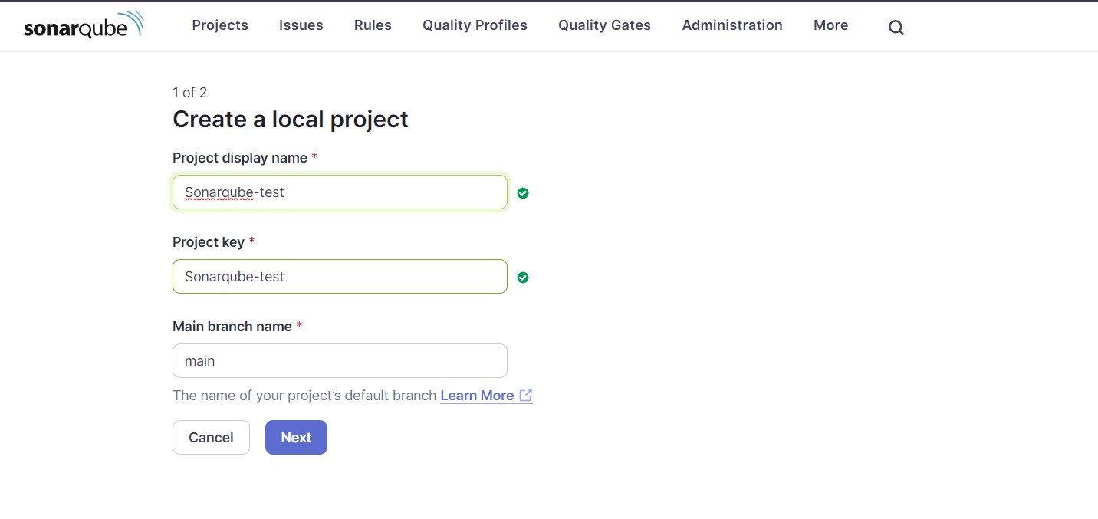

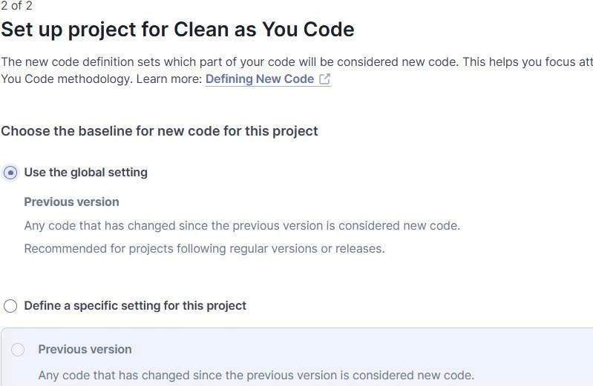

1. Open up Jenkins Dashboard on localhost, port 8080 or whichever port it is at for you.

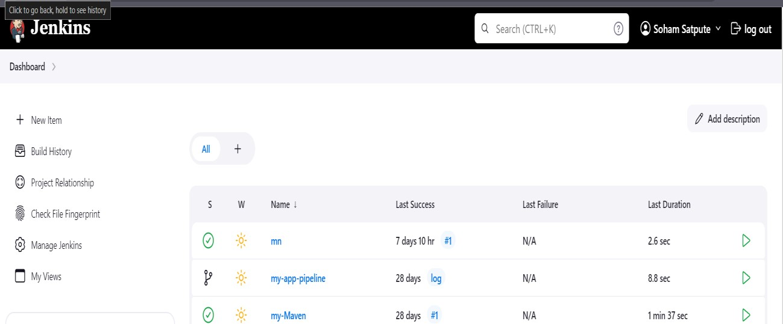

1. Go to Manage Jenkins and search for SonarQube Scanner for Jenkins and install it.

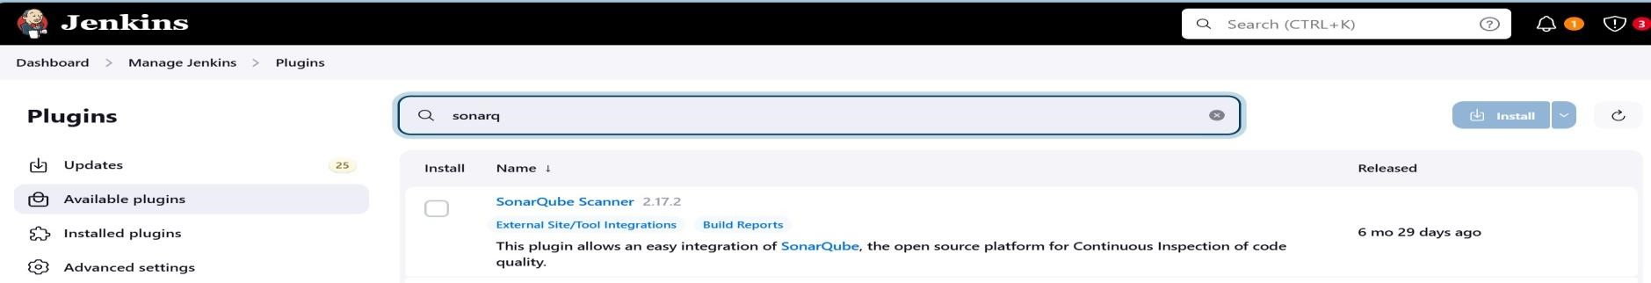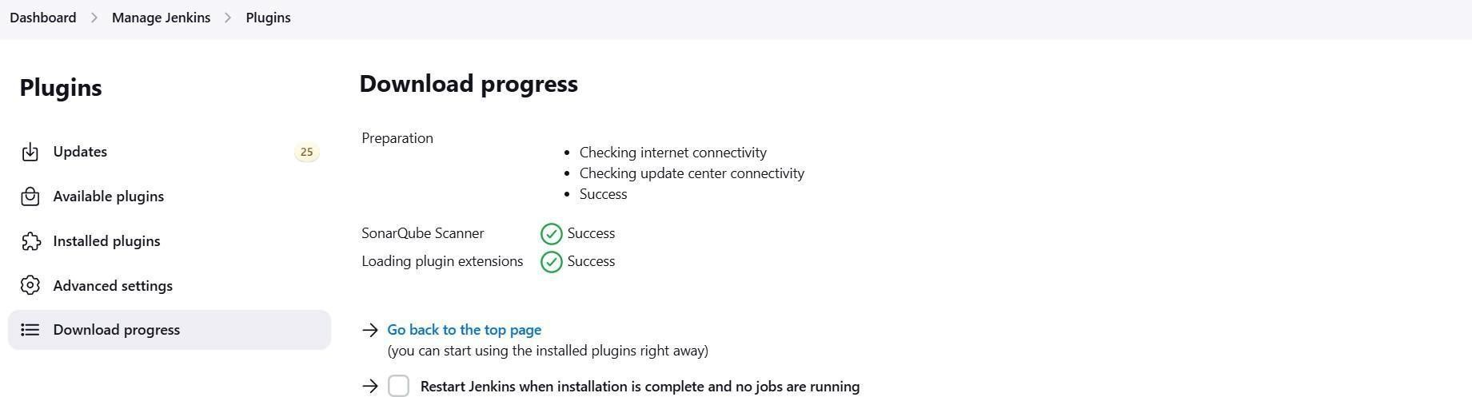

7.Under Jenkins ‘Manage Jenkins’ then go to ‘system’, scroll and look for **SonarQube**

**Servers** and enter the details.

Enter the Server Authentication token if needed.

In SonarQube installations: Under **Name** add <project name of sonarqube> for me **adv_devops_7_sonarqube**

In **Server URL** Default is [**http://localhost:9000**](http://localhost:9000/)

1. Search for SonarQube Scanner under Global Tool Configuration.

Choose the latest configuration and choose Install automatically.

**Dashboard > Manage Jenkins > Tools**

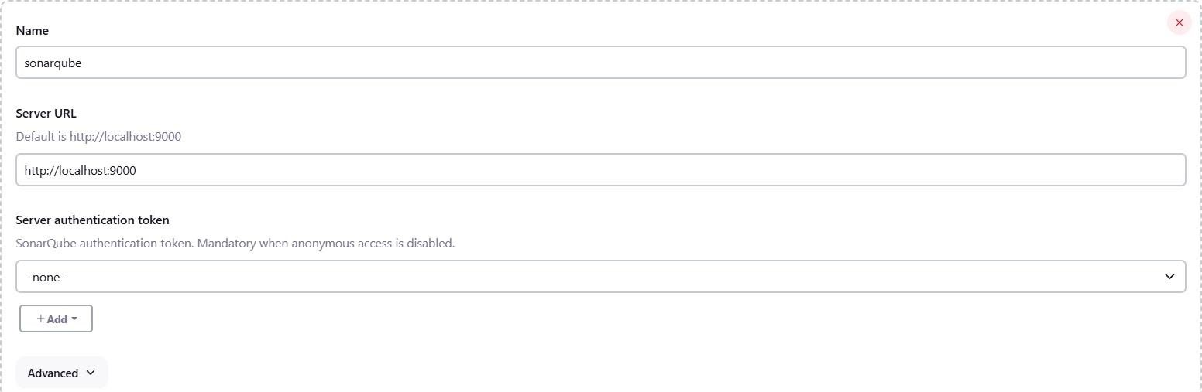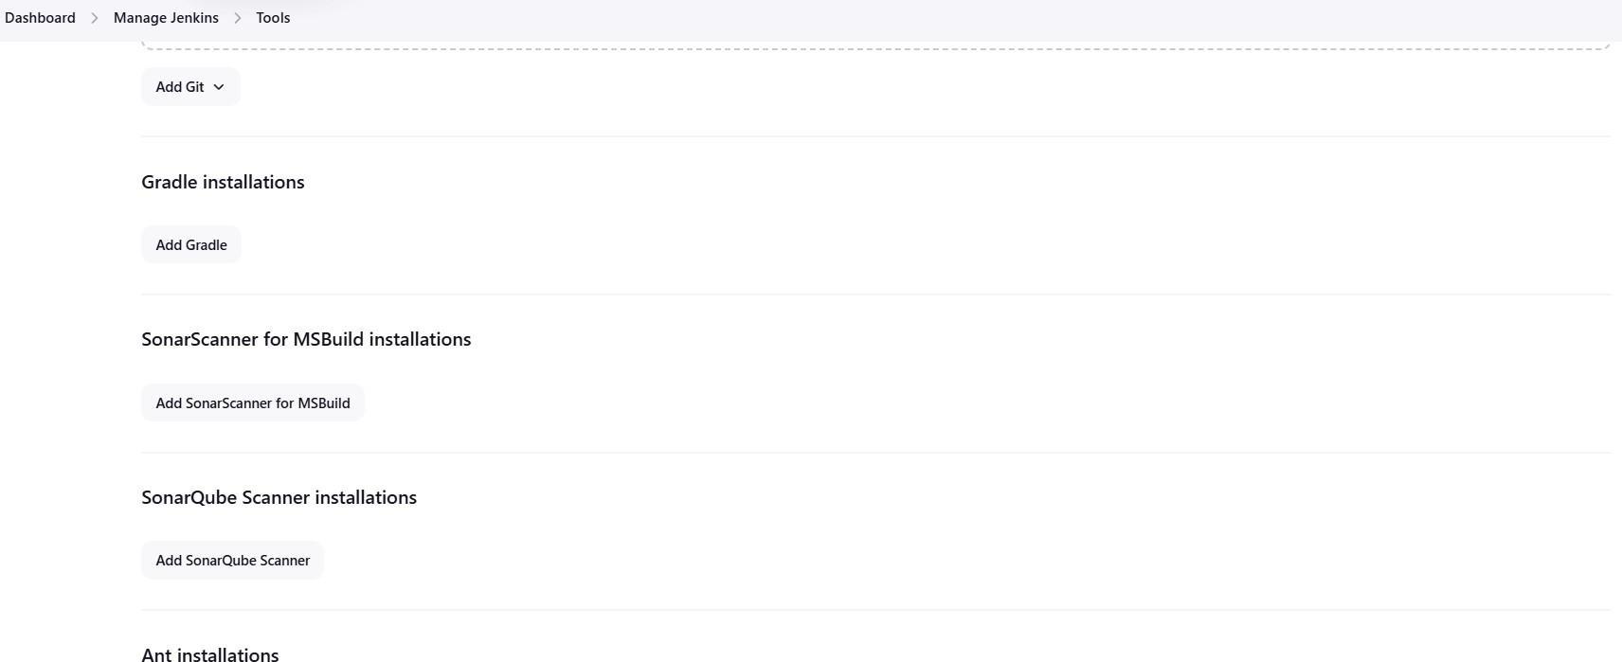

Check the “Install automatically” option. → Under name any name as identifier → Check

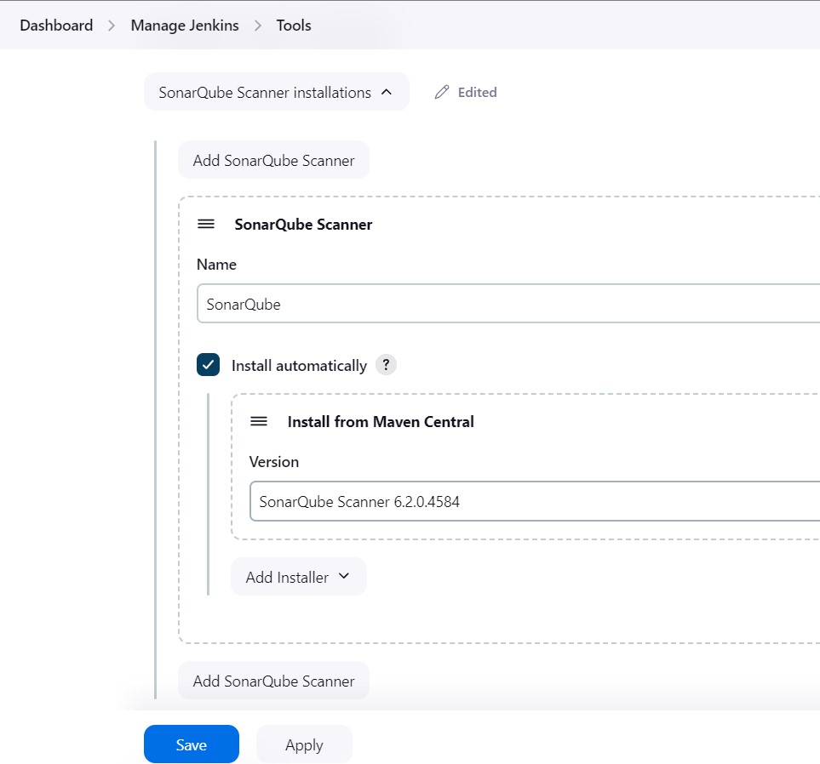

1. After configuration, create a New Item → choose a pipeline project.

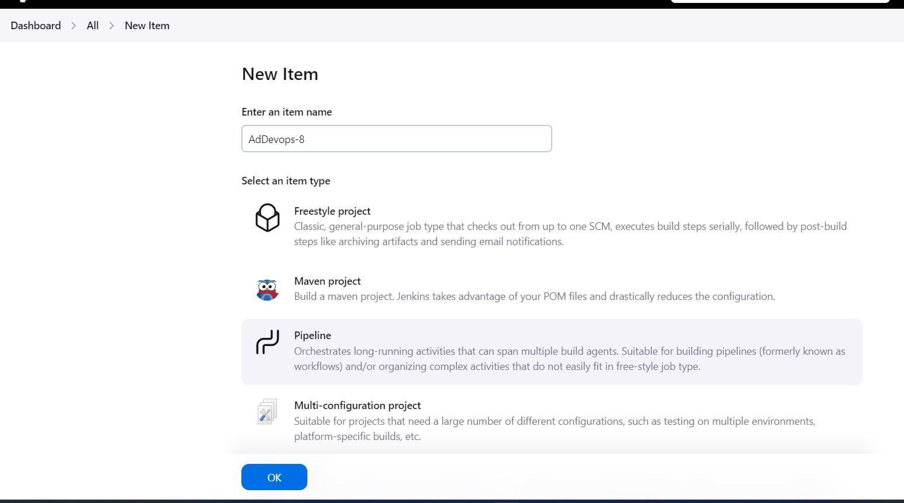

1. Under Pipeline script, enter the following:

node {

stage('Cloning the GitHub Repo') { git 'https://github.com/shazforiot/GOL.git'

} stage('SonarQube analysis') {

withSonarQubeEnv('<Name_of_SonarQube_environment_on_Jenki ns>') { sh """

<PATH_TO_SONARQUBE_SCANNER_FOLDER>/bin/sonar-scanner \

-D sonar.login=<SonarQube_USERNAME> \

-D sonar.password=<SonarQube_PASSWORD> \

-D sonar.projectKey=<Project_KEY> \

-D sonar.exclusions=vendor/**,resources/**,**/*.java \

-D sonar.host.url=<SonarQube_URL>(default: http://localhost:9000/) """

}

}

}

It is a java sample project which has a lot of repetitions and issues that will be detected by SonarQube.

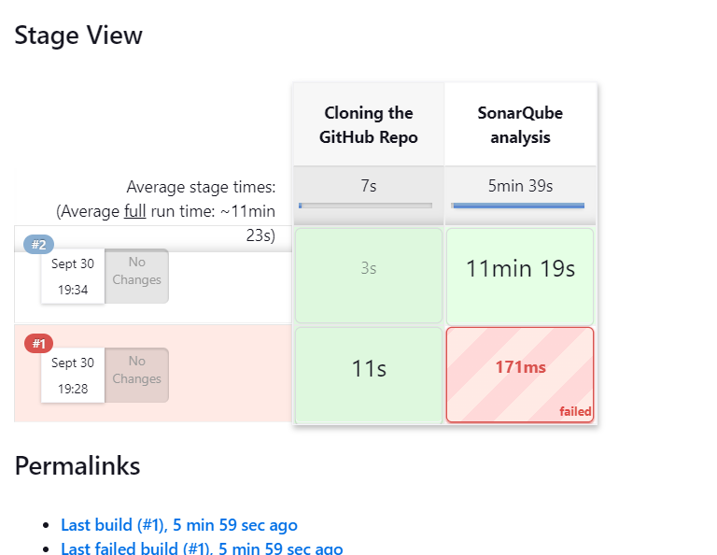

11.Check console

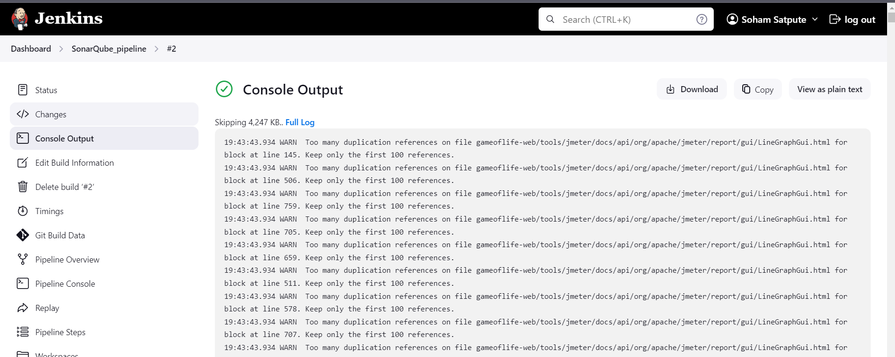

12.Now, check the project in SonarQube:

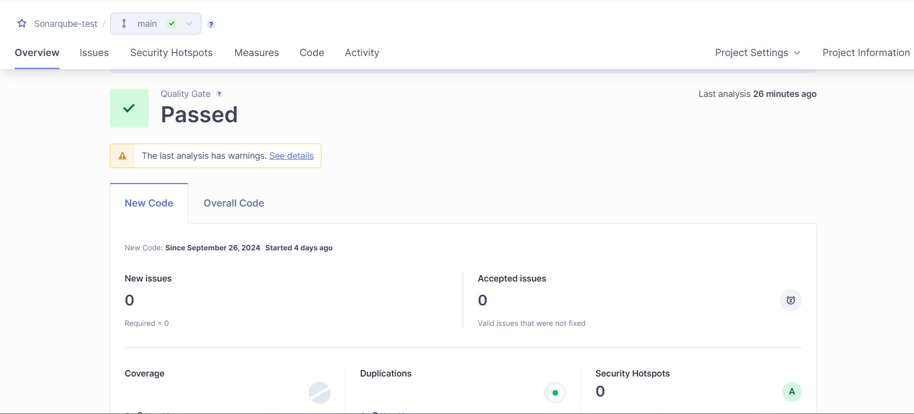

13.code problems consistency:

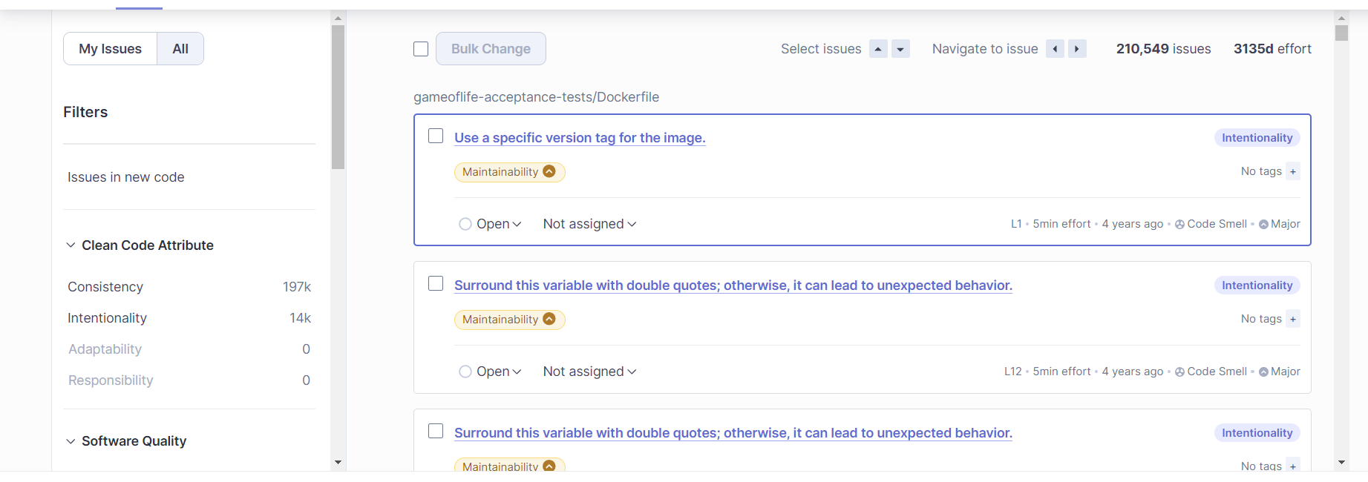

14.Intentionality:

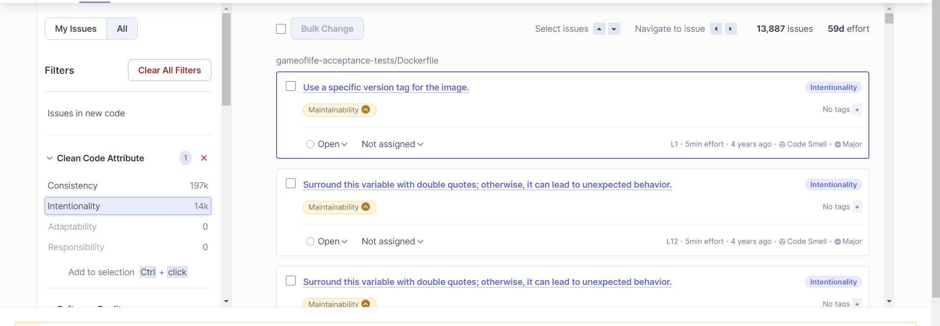

15.Bugs

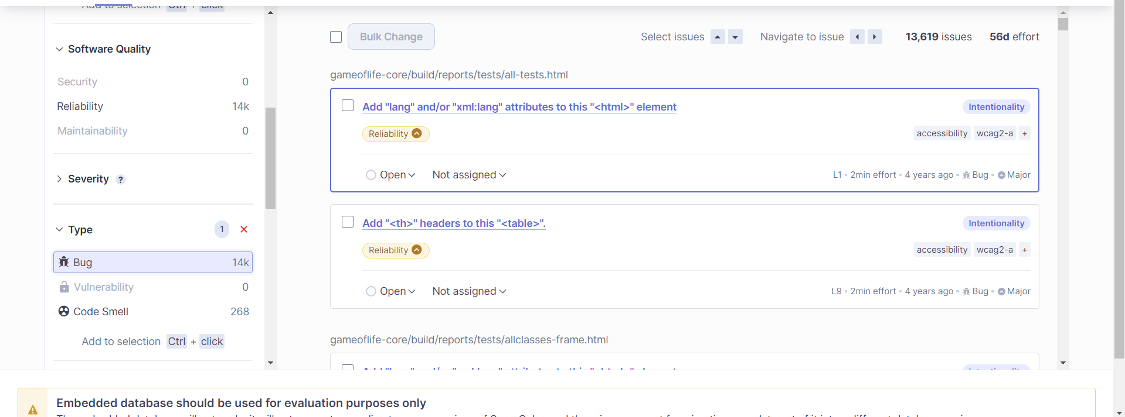

Code smells:

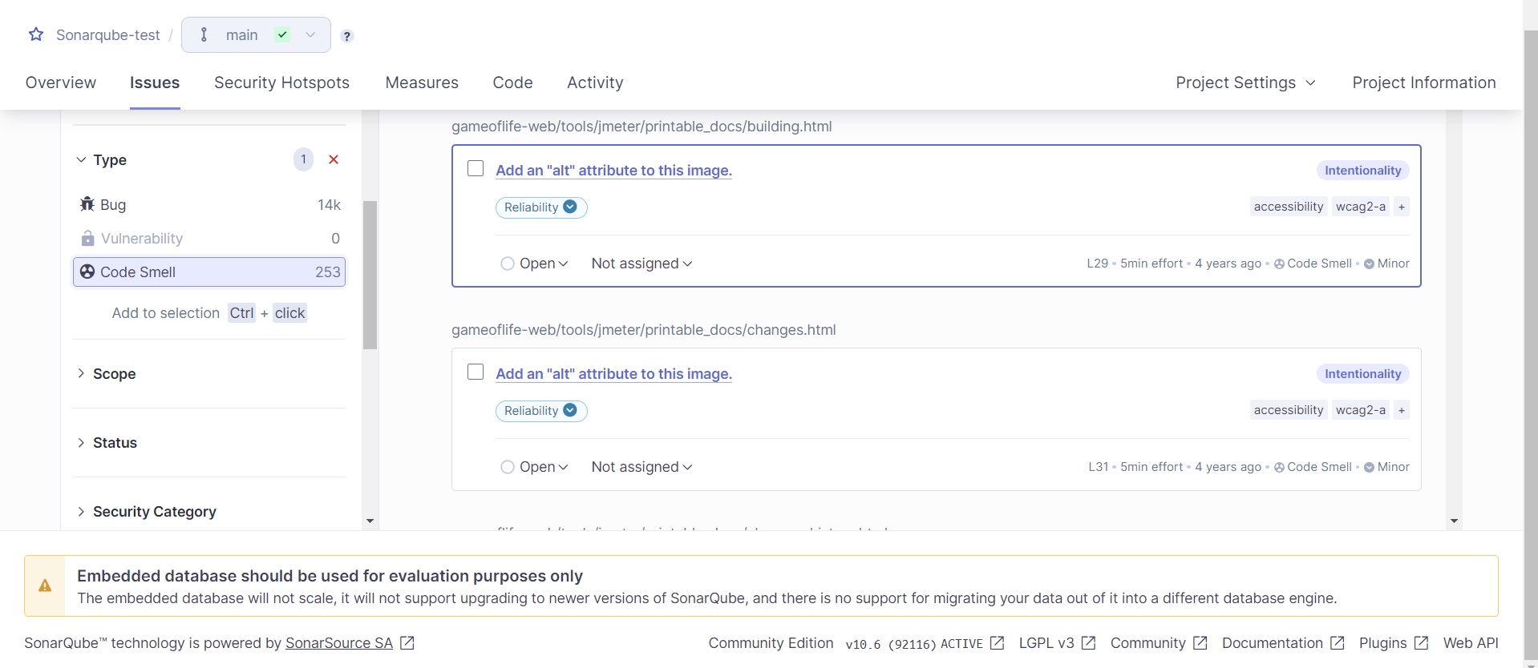

Duplications:

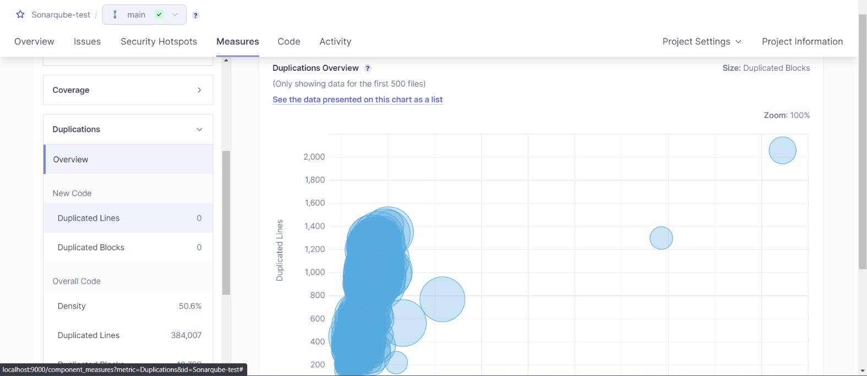

Cyclomatic Complexities:

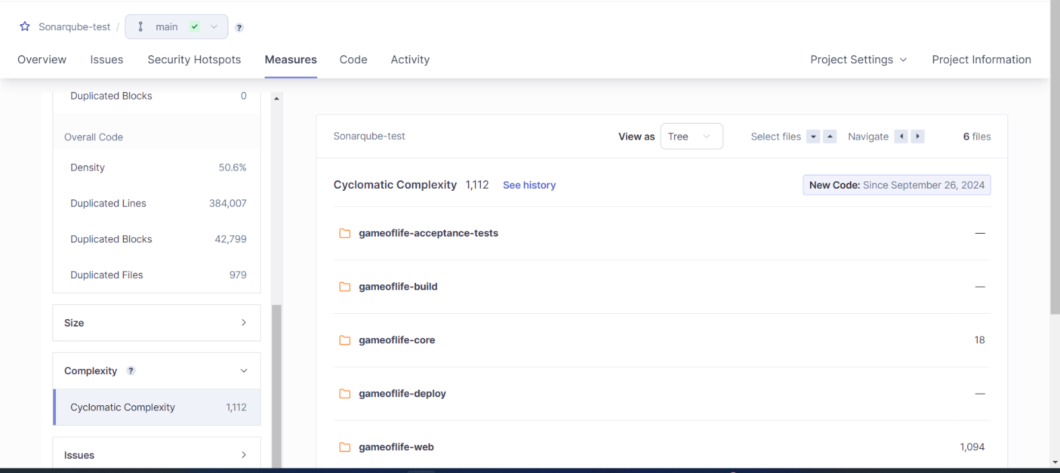

In this way, we have integrated Jenkins with SonarQube for SAST.